Task 2 Web Design Worksheet

(Each student to complete this booklet) the teacher will view this as a print out or from your files on your computer – each stage MUST be completed by each student and checked by the teacher)

X~tralicious

Web Page Project Title

Production Manager: Nadine Mak
Creative Designer: TJ King

Compiled By (include names and position)

The contents of this Web Design Worksheet have been set out according to the Technology Process –which involves Investigating, Devising, Producing and Evaluating. By completing it in detail you will be demonstrating some of the fundamental requirements of the Student Outcomes.

Note: Your final achievement level will be a combination of your Investigation, Devising, Production and Evaluation NOT just the final product.

Investigating ( Identify the requirements, issues, values, needs and opportunities associated with this task)

Identify the:

- Topic
- Target audiences characteristics
- Key design considerations

Devising (Describe your ideas, alternatives and opportunities)

Produce a:

- Time Plan
- Content Map
- Hierarchy Structure Chart
- Navigation Map
- Home & Template Screen Layout plan
- Prototype Storyboard (Splash page screen layout design)
- User Documentation
- Resource Records / Bibliography

Producing (products, processes, systems, services, environments)

Identify and justify:

- Selected software tools
- Production techniques and sequence

Evaluating (intentions, plans, actions, consequences)

Web Design Worksheet Proposal

Nadine Mak- blue
TJ King- pink
Together- purple

1. Technology to be developed
(What are you trying to produce, describe your web site?)

We are trying to produce a website which is promoting our company called X~tralicious. It is a modelling company where people can join if they would like to model or are a model and currently wanting to change to a new studio. It also features the requirements needed to be in the company and certainly you don’t have to be as skinny as a stick to join, just a healthy body and an average weight. Healthy options and healthy diets, there’s no need to gorge on the vegetables all day, still have the dietary needs your body needs without adding on the fats and calories. Also on our website are fashion gallery, latest trends and great shopping advice. DRESS TO IMPRESS!!!

2. Key Target Audience Characteristics:
(E.g. Age, Gender, Interests, Pre-requisite Knowledge, Motivations, Language and Wealth)

We are looking to appeal to the young adults and teenagers, such as females. We know how females love to keep their body in shape but some go over the limit when it comes to what it really means by “keeping in shape.” By coming to X~tralicious we give you the perfect body shape that you will be happy about when you are modelling up on stage. When it comes to interests, it really just anything to do with fashion and make-up and willing to just SHINE in the spotlight! The qualifications to be a model are that you have to be between 15 and 22 years old and are tall long legged and lean. Modelling is a career which you must be dedicated to. They are always calling you up to be willing and able to pose for a photo shoot no matter what. It is a career that is very demanding, and you have to prove yourself that you are worthy to be working in the modelling industry.

3. Key Design Features
(eg. What key features will you build into your technology and why.)

- Fashion Gallery
- Latest Trends
- Healthy Dieting
- About X~tralicious
- Join X~tralicious
- News
- Contact
- Covers/Editorials

The fashion gallery is a great way to interest the site viewers. It shows that the company has style and that there are ranges of new clothing to show, especially with the designers who are coming up with new ideas to improve the company and boost the appeal. It would be boring just to have the same style of clothing, there needs to be uniqueness and class to every dress. Latest trends are really important as we are sub-conscious in what we wear and want to look that extra perfect when going for an evening out, dressy casual clothing for just the shopping centre or the city and great swim wear for the beach, that’s sure to impress. Healthy Dieting is important for models as they have to keep their body shape. About X~tralicious is basically what we are all about. Joining our company is all about; how tall do I have to be, How to become a model, jobs you get by being a model and costs of photo shoots and joining fees. Contact is how to contact us and all the latest news on X~tralicious along with covers/editorials.

4. Societal / Environmental Considerations
(E.g. What societal or environmental factors might affect the development of your technology and why? – laws, boundaries, beliefs, conservation, health, employment, deskilling etc)

The societal or environmental factors that might affect the development of your technology are laws, boundaries, beliefs, conservation, health, employment and deskilling. Beliefs are the most important issue when it comes to our company since it is a modelling company. Muslim women are forbidden to show the contours of their bodies and certainly no tight clothing is allowed. The clothing that they are permitted to wear is long skirts and shirts, women are to dress modestly. When it comes to health, models are so obsessed with their weight that they forget what is considered “Acceptable”, they go overboard and become either anorexic or bulimic just to get down to a thin size. The laws and boundaries are the copyrighting of pictures off the website. If there wasn’t a copyright on pictures then anyone can take it and try and sell it. Included in laws and boundaries are protected subject matter and exclusive rights as well as organisational privacy (keeping some parts of the website closed off to the public, where access is only gained by a model or a top employee.)

Organisational Privacy is often used as we don’t know who could go on our website; other modelling companies competing with us could try and steal ideas just to make their company better. Through conservation, it is a way to develop short term and long term strategies to help maximise all profits and enhance the efficiency and effectiveness of the company. Employment is of strong importance nowadays especially with police checks. Police checks are important as some photographers or any employee could be a killer trying to find information on a particular model, maybe due to their wealth or jealousy of their wealth and beauty. An example of this is JonBenèt Ramsey, a little girl who entered beauty contests and pageants, was killed by strangulation due to her father’s wealth. Deskilling is the downloading and printing photo shots on the computer rather than paying extra money to get it printed in the same way, having people always working or otherwise just contracting them in so that we only pay a certain amount and that way everyone is working all the time which is maximum productivity.

5. Other Circumstances Affecting Production Techniques
(E.g. What other factors might affect the development of your technology and why? E.g. Mass Production Techniques, Marketing, Delivery, Budget, Time availability)

Other factors might affect the development of your technology are as follows; Mass Production Techniques, Marketing, Delivery, Budget and Time availability. Mass Production Techniques includes factories, space, repetitive programming, computing, someone to operate the computing and the cost of all the programming. Marketing is having contact cards for all models so that clients will be able to know who to use for advertisements and mass emails sent out to big corporations for models that they may be able to use. Delivery is emailing test pictures to the client, all finished photographs being hand delivered by an employee, and all models will have a certain hotel that they can stay in when on a shoot and fly with the same company. When it comes to Budgeting is buying web designing software such as Adobe Dreamweaver on its own is about $700 but to get it in a Collection you would have to pay $800 extra. Time Availability is to do with having a monthly planner, planning when some models can get out to a shoot and when they aren’t available, all details posted in the employee/model/client section.

Web Design Worksheet Annotated Web Pages

Annotate two web pages looking at layout, SPARC, colour, ease of navigation, ease of use plus any other critical analysis etc.
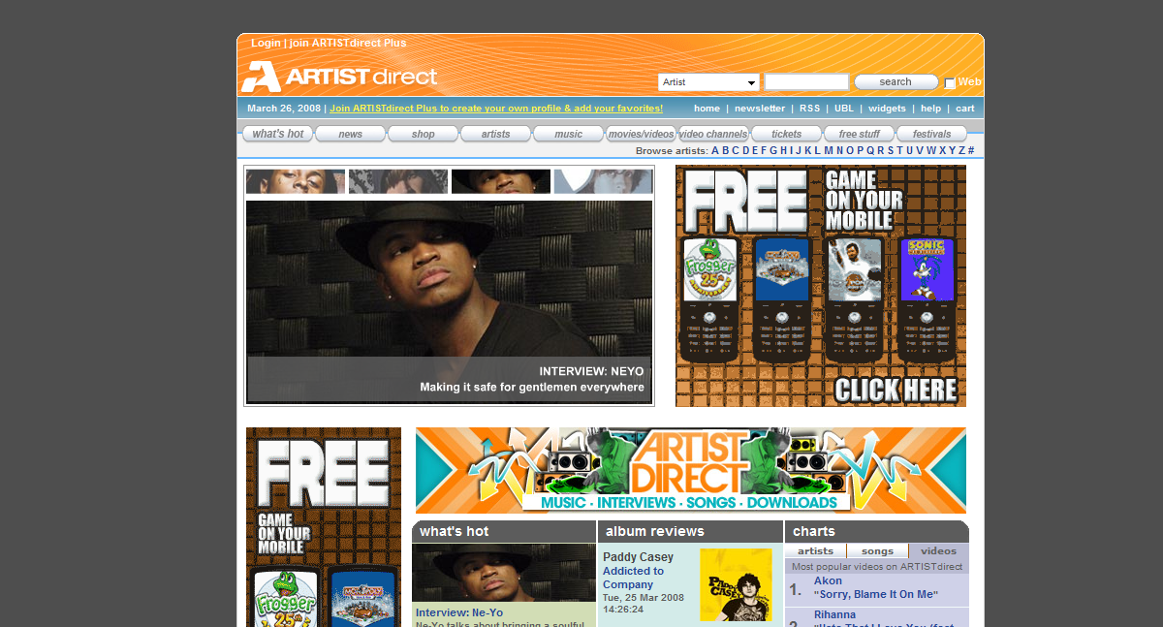

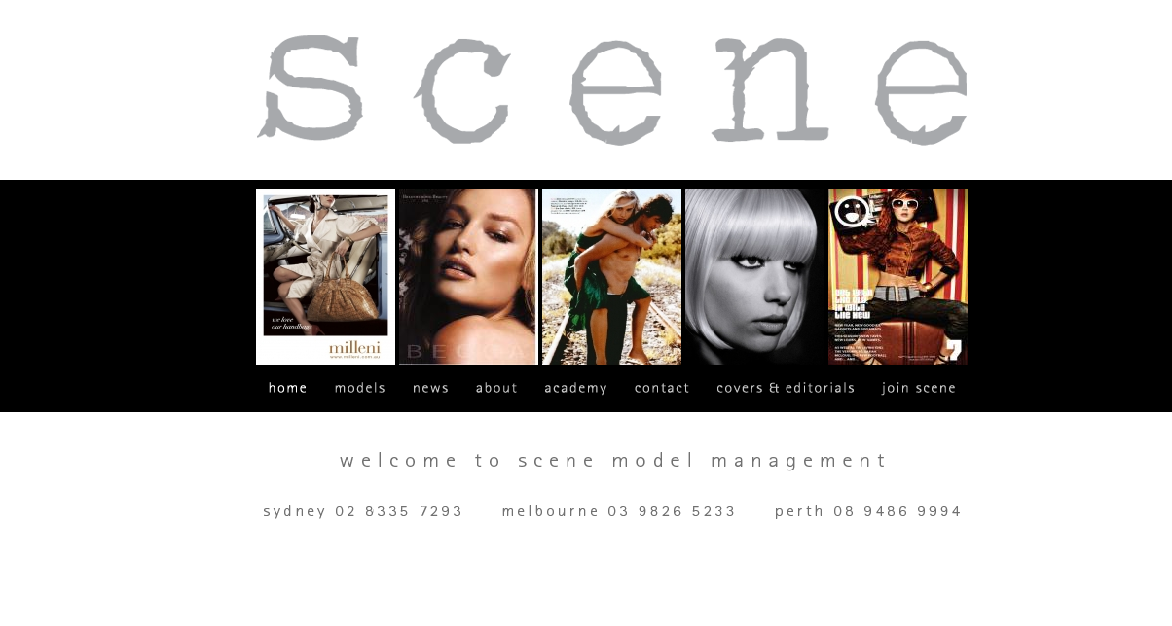

Style and Simplicity, Proximity and Position, Alignment and Arrangement, Repetition and Re-use, Colour and Contrast

Considering Artist Direct is a music website it promotes anything to do with music. The style of this website appeals to both teenage boys and girls who love music and want to listen to music for free. It is organised and positioned in a specific way so that the viewers have a variety of choices to pick out whether they want to listen to” what’s hot”, read album reviews or look at the charts and see who has topped number one in music. It attracts a lot of attention because it has pictures of a famous artist as shown “Ne-Yo” and by clicking that picture you can listen to his latest music. Pop-up ads also appear on this website and sometimes they promote “By giving in the correct answer on who sang “The Takes Over, The Breaks Over” you will win a free ring tone. This is put into style because teenagers have mobiles phones and we just love to have free ringtones on our phones. The simplicity of a website is really important because we want to keep our viewers on a website for a long time. By making it simple and easy to use they will always come back to same website. I chose this website because I keep coming back to it over and over again, as it has everything I need to know about music. Under each separate sub-heading you can find things easily without the hassle of looking for it or pressing lots and lots of buttons just to get to the web page that you want to get to. This is also the same with the Scene website. The proximity of this page is spaced out really well. There is equal amount of space between the pictures on the page. Proximity is important because when we want to see things clearly on a website. On some websites that haven’t applied proximity, subheadings go over other sub headings and we can’t see which button we are pressing. The background colour for this webpage is a dark grey colour. This contrasts with all the other colours because the grey brings out the other colours on the page making it brighter and makes it stand out. Alignment and arrangement

Web Design Worksheet Journal

13. Production Techniques and Sequence
(Throughout the construction of your product you should keep a daily LEARNING LOG. Use this to indicate specific production techniques and the sequence of events ie. Did you follow your initial time plan?)
 | Name | Nadine Mak
Day | Date | What I Did | Problems | Solutions
1 | Tuesday 18 March 2008 | - What the website is about and what we are trying to produce  - Key Target Audience Characteristics | Trying to find out what motivation is needed if you were a model, I did a bit of research with no luck | As the research did not help, I decided to think for myself what motivations are needed when it comes to modelling and a little bit or help from my partner as she has a friend that does modelling.
2 | Wednesday 19 March 2008 | Key Design Features  (E.g. What key features will you build into your technology and why.)  Content Map  - About X~tralicious  - Fashion Gallery  - News  - Latest Trend | No problems there  For the Content Map, I have trouble thinking what links to put in | None  Looked at modelling website to see what they put under their sub headings and try and incorporate it in.
3 | Thursday 20 March 2008 | Completing my part on Content map | No problems
4 | Friday 21 March 2008 (GOOD FRIDAY)-Tuesday 25 March 2008 (Easter) | Unable to catch with my partner during these days, though we did my part on content map as well as Hierarchy Structure Chart which TJ sent to me. Though it isn’t finished as she was studying for other subjects. I also did Screen Layout Plan. | No skills and hardware needed, just a basic designing skill.
5 | Wednesday 26 March 2008 | Content Map: News  Hierarchy Structure Map: Home | I had trouble finding what to put on a how page and a News page | Looked up two modelling websites and found some ideas from there
6 | Thursday 27 March 2008 | Evaluation  Journal Time Planner
Person 1

14. Daily Learning Log (Who did what?)
(Make a comment each day about your learning experiences, problems and solutions. This can be using the electronic learning log. A sample is shown below – make more rows as required)
 | Name | TJ King
Day | Date | What I Did | Problems | Solutions
1 | Tuesday 18th march 2008
 | Wednesday 19 March 2008

Student: Nadine Mak Task: 2 Teacher: Mr Faulks

Journal or Time Planner

 |  |  | Mark when done
No. of Lessons |  |  | 1 |  | 2 |  |  | 3 | 4 | 5 |  | 6 |  | 7 |  |  | 8 |  | 9 |  | 10 |  | 11 |  | 12 |  | 13 |  | 14 |  | 15 | 16 |  | 17 |  | 18 |  | 19 |  | 20 |  | 21 |  | 22 |  | 23 |  | 24 |  | 25 |  | 26 |  | 27 |  | 28
Students Initials & Task
Tasks / Activities Tick when done |  |  |  | Tuesday 1 8 March |  | Wednesday 19 March | Thursday 20 March 2008 |  | Wednesday 26 March 2008 |  | Thursday 27 March 2007

Technology to be developed
(What are you trying to produce, describe your web site?)
Key Target Audience Characteristics:
(E.g. Age, Gender, Interests, Pre-requisite Knowledge, Motivations, Language and Wealth)
Key Design Features
The key features to be built in our technology

Key Design Features
WHY?
Content Map
About us
Fashion Gallery

Content Map
Latest Trends
News

Other Circumstances Affecting Production Techniques

(e.g. What other factors might affect the development of your technology and why? E.g. Mass Production Techniques, Marketing, Delivery, Budget, Time availability) [dot points only]

Other Circumstances Affecting Production Techniques

(e.g. What other factors might affect the development of your technology and why? E.g. Mass Production Techniques, Marketing, Delivery, Budget, Time availability) [rewording the dot points and putting into paragraphs]

Societal / Environmental Considerations
(eg. What societal or environmental factors might affect the development of your technology and why? – laws, boundaries, beliefs, conservation, health, employment, deskilling etc) [dot points only]

Societal / Environmental Considerations
(eg. What societal or environmental factors might affect the development of your technology and why? – laws, boundaries, beliefs, conservation, health, employment, deskilling etc) [rewording the dot points and putting into paragraphs]

Have your teacher sign off on this document
prior to starting your task construction.
Signed

Web Design Worksheet Content Map

5. Content Map
Links =

Latest Trends
Fashion Gallery

About us

Evening Wear

Summer Fashion
Swimwear

About X~tralicious
Who are the designers?
Bags

Autumn Fashion
Winter Fashion
Shoes

What is expected at X~tralicious
Spring Fashion
Purses

Contact Us

Link to make up artists
TOPIC

Modelling

New Photo shoot sessions
X~tralicious Touchdown
HOT NEWS on top models
Updates
Term Dates
TJ
TJ
News
TJ
Web Design Worksheet Sample (change to suit) Hierarchy
Fill in the pages add links and structure your site

Splash Page (page 1)
- Welcome
- Our Location
- News & Events
- Stock Catalogue
- Promotions
- Services
- Sign Our Guest Book
- About Us
- Copyright
6. Hierarchy Structure Chart
Page 8
(NEWS)
Page 3
(ABOUT US)

- Updates
- New Photo shoot session
- X~tralicious Touchdown
- Term dates
- HOT News on top models
- Evening Wear
- Swimwear
- Bags
- Shoes
- Purses
- Covers of magazines with our models
- Requirements
- How Do You Become a model
- What sort of jobs you get as a model
- Where do models live
- Why do I need a comp card?
- About X~tralicious
- What we are looking for
- New designers

Page 9
(Latest Trends)

Page 6
(Join X~tralicious)
- Pilate Classes
- Fitness Club
- X~tralicious Healthy Corner
- Employ your own make-up artists
- Contact Us
Page 7
(Covers and Editorials)
- Maintaining a healthy diet
- Get fit in four weeks
- Exercise

Page 5
(Healthy Dieting)
Page 4
(FASHION GALLERY)
- Summer Fashion
- Autumn Fashion
- Winter Fashion
- Spring Fashion

Page 2
(HOME)
- Home
- About Us
- Fashion Gallery
- Latest Trends
- Healthy Dieting
- Join X~tralicious
- Covers and Editorials
- News
- Member Login
Page 1
(INDEX)
These are hyperlinks
Web Design Worksheet Files & Folders

7. Navigation Plan / Folder Structure
(Demonstrate that you have thought about the structure and appearance of your product)

SAMPLE ONLY

E.g.
topic name
home.htm
Images
Subtopic 1
E.g.

Screen shot - Print screen of your site files and paste it here
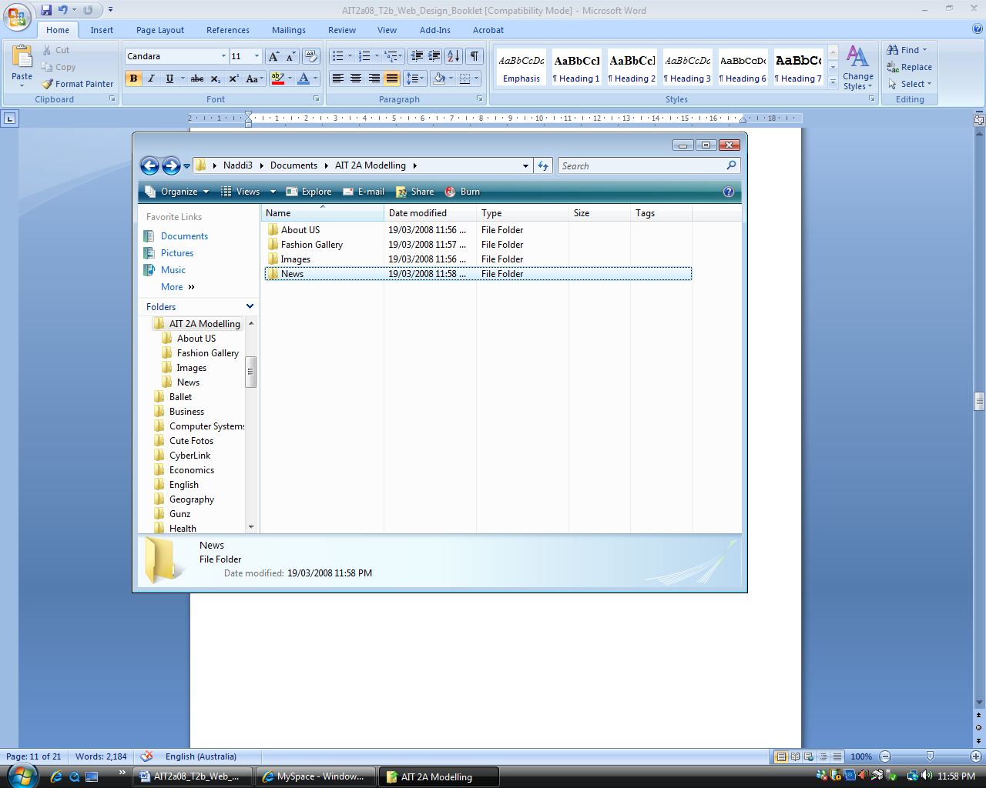

Web Design Worksheet Draft Sketches of Main Screens

8. Screen Layout Plan
(Draw the basic screen layout demonstrating sound design principles. e.g SPARC)

X~TRALICIOUS

Picture
Picture
Picture
Picture

Home About us Fashion Gallery Latest Trends Healthy Dieting Join X~tralicious Covers and Editorial News

Contact US

Home Screen

X~TRALICIOUS

PICTURE
Home About us Fashion Gallery Latest Trends Healthy Dieting Join X~tralicious Covers and Editorial News

Screen Template
(This shows the position of repeating elements ONLY)

Web Design Worksheet STORYBOARD

9. Storyboard
(Where appropriate you may need to draw a layout design for other key screens indicating the exact content and design features such as Graphics, Sound, Animation, Colour etc.
Continue onto a separate page as necessary)

- Key Features: About X~tralicious

Key Features:

Key Features:

Web Design Worksheet Evaluation Sheet

10. What did you do to plan this web page
(What support information will your target audience need to effectively use your product?)

details:

[Type your response here.]

Have you provided On-screen Help how = details:

[Type your response here.]

11. Resource Record - Bibliography
(What resources have you or do you intend to use to create your product? You should have at least one from each of the following categories)

People: (Name; Position; How found)

1. Nadine Mak; Production Manager

2. TJ King; Creative Designer

Electronic Resources: (Web Sites, CD-ROMs, On-screen Help, Tutorials, Videos etc)

add more lines

- www.google.com, www.wikipedia.org,

- Tutorials, videos, flash

3.

Non-Electronic Resources: (Books, Magazines, Newspapers, etc)

1.

2.

3.
Web Design Worksheet Evaluation

12. Selected Software Tools
(What software did you use to create your product. What features of the software made it particularly suitable for the way you used it?)

- Program: Adobe Dreamweaver

Reason for use: The reason for using this program is because this software allows you to make a website easily.

- Program: Adobe Fireworks

Reason for use: It is a great way to design headings, and you can style the heading to catch the reader’s attention.

- Program:

Reason for use:

- Program:

Reason for use:

Task Evaluation
Consider your task carefully and critically evaluate your work by answering the following questions.

1. What was the purpose of your task?

The purpose of this task was to complete a web booklet which is the background help to produce later a real website program to promote our company or product. There are two people per group and each person had a specific part in the assignment at which they completed. This task also helped develop our understanding of SPARC which is of importance when designing a website, so as to appeal to the nature of our audience and keep them interested in our website. The Hierarchy Structure Chart an organised way to set out what is needed under each sub-heading to save time in figuring which should go under each heading or which page goes where. By referring to this structure chart we are able to complete a well structure website. The storyboard helps so that we remember what we want in the web page such as graphic, colour, animations and sounds.

2. Who was your intended audience of your newsreader background?
Our intended audience are 15-22 years old as this is the age that teenage/adult models have to be to enter our studio.

3. How well do you think your design suits the intended audience?
□  Very well | Quite well | □  Not sure | □  Could be improved | □  Audience not considered in the design

4. Have you been able to test your design on someone from your intended audience group?
What was their reaction?

No we haven’t been able to test our design yet on our intended audience as we are only just producing a plan of what we will be doing.

5. How many samples were you able to view to help you investigate your design?
□  None | □  1 or 2 | About 5 | □  Between  5 and 10 | □  More than 10

6. How did you decide which software to use for your background?
□  I produced several versions in different software and chose the best | □  I did some drafts in a couple of applications and chose the best one to complete it in | I began using one application and swapped to another when my skill levels increased | □  I only used one of the suggested applications | □  I only tried word processing software

7. How original was your design?
□  I copied a design I had seen elsewhere | I copied a design and changed the colouring and shapes | □  I used a variety of designs and combined different aspects of them | □  I used a variety of ideas as inspiration and then developed my design | □  Completely original

8. Did you produce and keep draft copies of your background and your written response?
□  Yes, my pencil and paper drafts are in my hardcopy portfolio and my digital copies are in my electronic portfolio | □  Yes but only a digital draft version | Yes but I only kept a hardcopy draft | □  Yes I did but I didn’t keep any copies | □  No, only a final copy

9. Are you happy with your image manipulation skills at this stage?
□ Yes No
Explain

There are no image manipulations skills needed for this task

10. Would you like to develop your skills in image manipulation further since completing this task?
Yes □ No

11. Did you find any restrictions to your ability to manipulate your images?

There are no pictures to manipulate

12. Did you check your task for spelling and grammar mistakes?
Yes □ No

Why / Why not?
I always check my spelling and grammar, because we lose marks if our sentences don’t make sense and work should always make sense to someone reading it. It is also awkward to have bad spelling considering that we are Year 11 and Year 12 students.

13. How did you feel about your time management for Task 1?
□  I need a lot more time to finish my event item properly | I spent more time than suggested in preparing my event item | □  It took me about the same time suggested in the course to complete my event item | □  I was able to work quite quickly and had some time to spare | □  I worked very quickly and was able to spend time refining my item through learning more application tools

14. Have another look at the Scenario and the Task 1 Explained. Do you believe this item meets the requirements of the task? Explain

Yes I believe that this assignment meets the requirements of the task

Save your evaluations as (your initials)_task1_eval into your Week 10 portfolio.
Send a copy to me at the end of the week.

Rate yourself in the boxes below on the following criteria

AIT (Level 4, 5, 6 or 7)
- For each box  - Rate Your score in each based on the following: | Satisfactory High Very High
 | 4 | 5 | 6 | 7

                - Type your score here

Ability to locate information & research without any assistance | 7
Shows initiative | 6
Leadership/Planning Qualities | 6
Application to the task | 6
Time Management | 6
Works without any ‘nagging’ from the teacher | 7

- Did you personally enjoy investigation of your task?
Yes

- Yes / No Why

Well I did enjoy this task, as it helped me design a well structured website and I learned about SPARC as I didn’t really know what was meant by that specific term. There are many laws, boundaries, beliefs, conservation, health, employment and deskilling involves when making a website. Beliefs are important because we can’t really aim our website to Muslims as the men will get offended, it is the women’s modesty to cover her body from top to toe, nothing tight to show her curves.

- What are some things you liked / disliked about this task?

Well when you are working in a group you would expect your partner would do the equal share in it as well, but I had to force my partner to do her part and it wasn’t really as detailed as I have expected it to be. I had to help her make it more detailed, but eventually she decided to try by doing something on it. TJ is a partner that needs to be more motivated in her work and even though she is my friend but she really needs to work on involvement in her work and use her initiative a bit more. I feel that I was able to do my part because I was motivated to do it and it isn’t a really hard task if you really try.

Present this worksheet for each phase starting with your proposal…

If as a printed copy - it will be regularly returned to you during the task for updating or electronically checked on your computer.

- Proposal
- Draft Ideas –hierarchy
- Storyboard
- Journal
- Evaluation

